39.10: 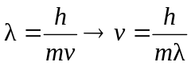
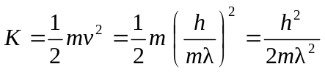
They will not have the same kinetic energy since they have different masses.
